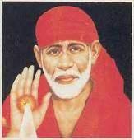 **SAAI MEMORIAL GIRLS SCHOOL**

**SAI BHAWAN, GEETA COLONY,**

**DELHI-110031**

**Documents Required for Admission in Pre School, Pre Primary and Class I**

1. **Date of Birth Certificate of the Child in Original and photocopy.**
2. **Aadhar Card of Father and Mother in Original and Photocopy.**
3. **Aadhar Card of the Child in Original and Photocopy.**
4. **2 Passport size Photographs each of Child, Father and Mother.**

**For the First list of selected candidates the last date for admission is 28th January’25.**

**The last date for admission for waiting list candidates in the above mentioned classes is 2nd February’25.**

**PRINCIPAL**